**STAR ENGINEERING WORKS**



**MECHANICAL ERECTION INSTALLATION & FABRICATION**

**Plot # 44, Ismail Goth, Mansehra Bus Stop, Landhi Karachi-31.**

Tel: 5016539

Tel: 6029629

Fax: 5016539

M. Aslam Cell # 0333-2102752

M. Arshad Cell # 0333-2173716

E-mail: star_engineering2001@yahoo.com

***TO WHOM IT MAY CONCERN***

This certify that <Name> S/o <fname> has worked with us as a “<Designation>” with effect from <From> to <To>.

During his job we have found him hard working, honest and dedicated to his job Responsibilities. His colleagues and subordinates hold high regards for him and his talent. He has proved himself a highly productive employee and took all responsibilities given to him with enthusiasm and positive approach.

We wish him best of luck for his future

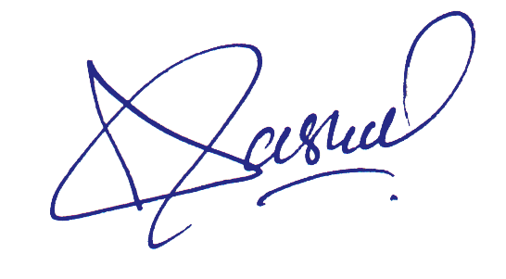

**Chief Executive Muhammad Aslam**

**__________**